COGNIZANT

WEEK 1 : MODULE 4 : TDD – JUNIT BASIC TESTING EX

EX 1: OUTPUT: SETTING UP JUNIT
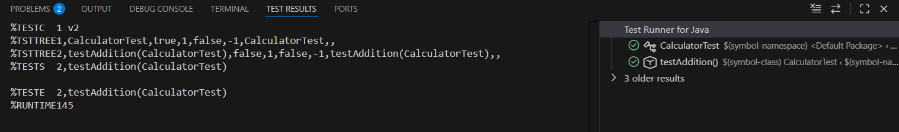

EX 3: OUTPUT :ASSESRTIONS IN JUNIT

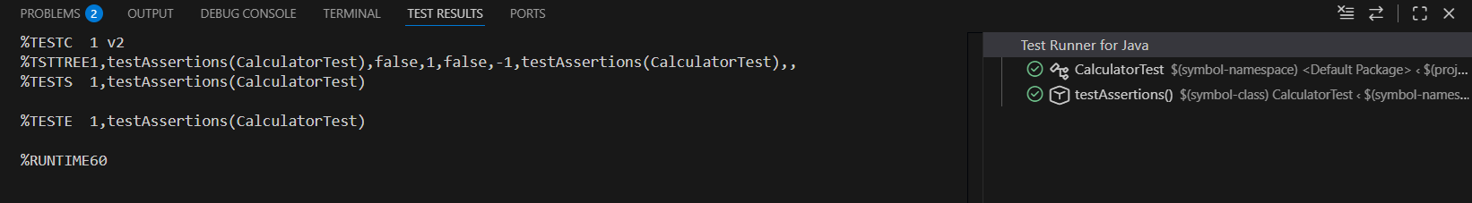

EX 4 : AAA PATTERN TEST FIXTURES

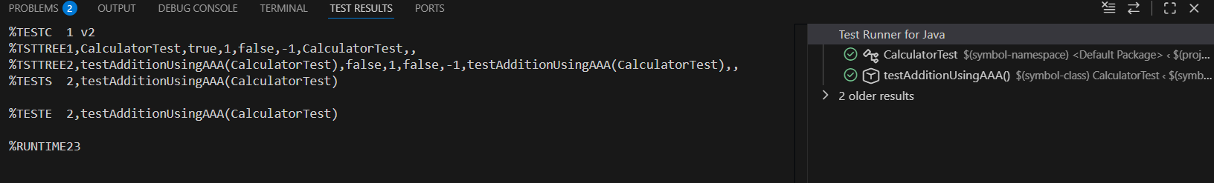
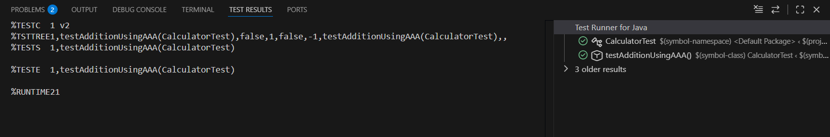

MODULE 4: MOCKITO EXERCISE

EX 1: MOCKING AND STUBBING
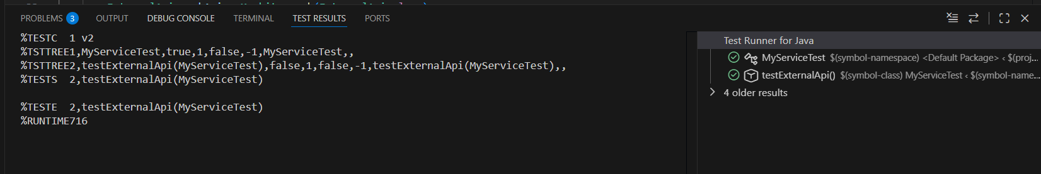

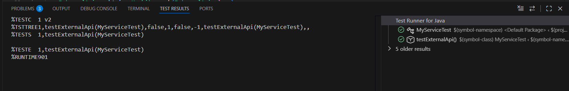EX 2: VERIFYING INTERACTIONS
